Free Keyboard System

The Free Keyboard System is based on “Auto hotkey” (www.autohotkey.com) which is an open source project, therefore, it can be used and distributed free of charge.

If you find an error or have suggestions for improvement, send an e-mail to: Hans_Schaumberger@sil.org.

Could you do me a favour? If you find it usefull, send me an e-mail and tell me in which organisation, university and country you are using it. I WILL NOT give this informations to anybody or send any e-mails to you!

Overview:
1. Every script is a standalone and executable.
2. More than one script can run at the same time.
3. The scripts communicate with each other.
If one script is activated, then all the others are deactivated.
Selecting / unselecting the compatibility mode affects all the scripts at the same time.
4. Scripts can be activated through a shortcut, a mouse click, or language selection.
5. Scripts can be made “language sensitive”.
6. Shortcut keys can be freely chosen.
7. The scripts can be made to start automatically when Windows starts.
8. Scripts can run from flash drives or other removable media. No installation is required.
9. Sourcecode is provided, so you can modify it or create new keyboards. The source code is installed under "Program files\FreeKey\Source".

When the script is started, a script symbol appears on the taskbar. The symbol is different for each script.
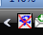

Menus on the script symbol
If you left click, the following popup menu appears.

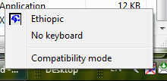

1. First line: The name of the keyboard system.
2. No keyboard: Switches the script off.
3. Compatibility mode: Since some older applications cannot handle Unicode input (e.g., Paratext, Toolbox 1.4 and others), this switch activates a different system which allows you to type in this program.
Disadvantage of this mode: It’s a bit slower and it uses the windows clipboard, so any content on the clipboard is destroyed when typing.

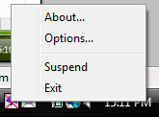
If you right click, the following popup menu appears.

1. About dialog
The following dialog box opens with detailed program information.

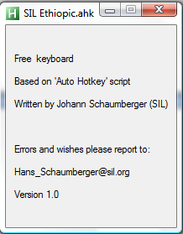

2. Options dialog
This dialog box has two tabs.

a. Basic Settings
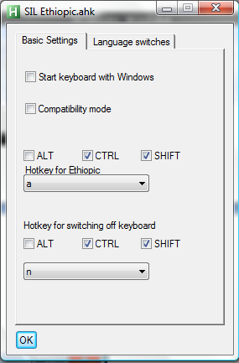

Start keyboard with Windows: Starts the keyboard automatically when Windows starts.

Compatibility mode: Uses a different sending system for working with older applications (as mentioned above).

Hotkey for “language name”: Allows you to select a shortcut key for activating a script.

Hotkey for switching off keyboard: Allows you to select a shortcut key for deactivating all scripts.

Caution: If you define different keys in different scripts, then all of them work in all scripts. For example, if you have two scripts and in one “n” is defined for switching off and in the second “m” is defined for switching off, then “n” and “m” will always switch off all scripts ... even scripts which do not have a key defined.

b. Language switches

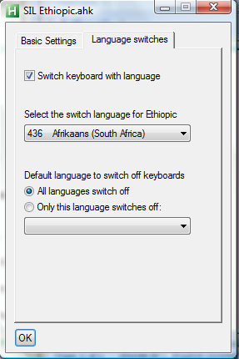

Switch keyboard with language: Enables or disables a language’s sensitivity.

Select the switch language for “language name”: In the drop down box, you find all installed languages. Select the one you want.

Default language to switch off all keyboards
All languages switch off
Only the selected language switches off

Select “All ...” if the keyboard should be switched off when the language changes or ...

Select “Only this language ...” if the keyboard should be switched off when a specific language changes. If you select “Only this language ...” then you must select the desired language from the drop down box.

